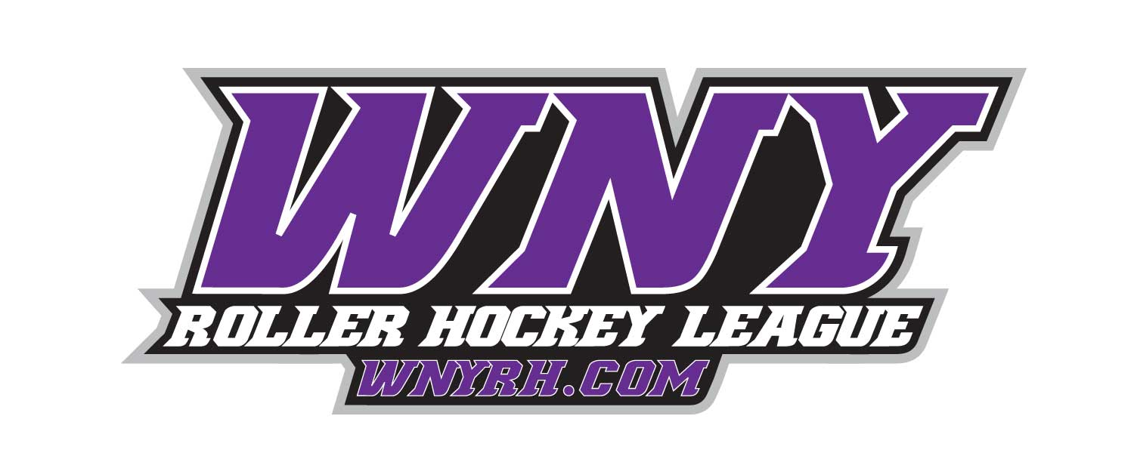

***2018 30+ FALL Draft League***

***Intended for Beginner to Intermediate Level Players***

**Monday Evenings beginning Sept. 17th at 7pm**

**\*Designed for beginner to intermediate players**

**\*Week 1 will be used to evaluate players. Teams will be picked for the remaining weeks and actual games will be played.**

**\*All sessions will be held at the -**

***Kenan Center Arena***

***433 Locust St***

***Lockport, Ny 14094***

All Participants will be required to have WNY Roller Hockey Membership ($35)

Membership is effective from Sept. 15th, 2018– September 14th , 2019

membership forms will be available at the rink during registration

**Up to 12 Week Session—$165 (player) $120 (goalie)**

**\*A full season schedule will be posted on our web site. Please check on Rink Calendar for dates and times.**

**\*For more Information please contact Eric Haak—716-903-2658 (Eric@wnyrh.com) or Jason Flowers—716-444-2667**

***For additional information on all of our programs visit***

**www.wnyrh.com**