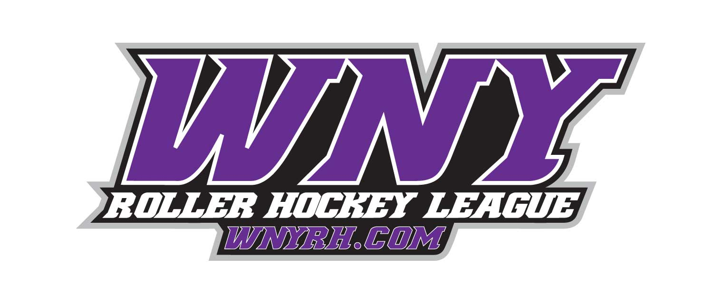

• Awards for 1st & 2nd Place teams

• Awards for League MVP, Top Goalie and Championship MVP

• Player of the Month Awards in each Division

**DIVISIONS:**

**Sunday**—Adult Aluminum, Iron, Copper, and Bronze League

**Monday**-Youth Skills and Drills, 30+ League and Bronze/Silver

**Tuesday**— Adult Iron, and Copper

**\*Payment\***

**$150 Deposit required at time of registration**

$25 off 2nd team

**$147** per skater if your roster size is 8 or 9 players

**$167** per skater if your roster size is 7 players

**$192** per skater if your roster size is 6 players

**Goaltenders**—**$120** (can play on multiple teams with in division)

• **For more info on registering your team please contact Jason at 444-2667 or email eric@wnyrh.com**

***NEW 12 Game Session! (Space is Extremely Limited!)***

_________________________________________________________________________

**@ The Kenan Arena in Lockport**

**Fall Session Begins Jan. 13th 2019**